Website Writings

I am too protective.

Where did these thoughts come from? Why can’t I cope with them?

Why can’t things be normal? Why do folks go out of their way to show me? And what am I supposed to do about it?

12/29/2016

How IKEA Is Redefining Customer Experience

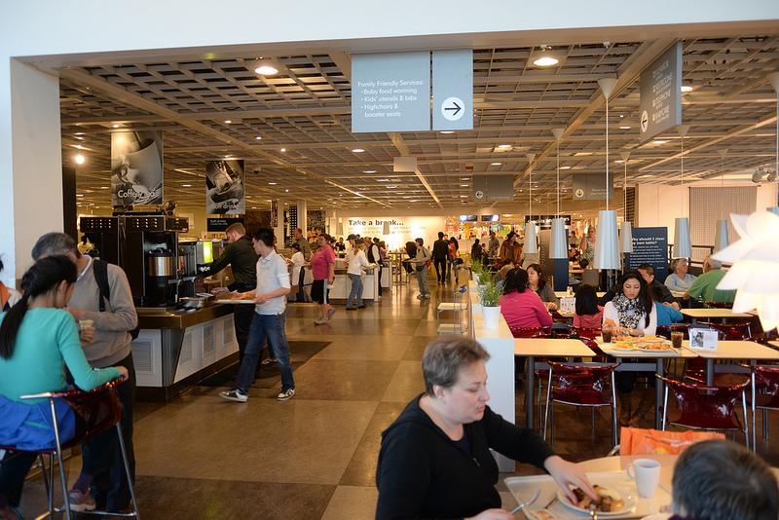

*Mygola*

This may look like a picture of a restaurant, but it’s actually of one of the biggest furniture sellers on the globe. Why may IKEA have play structures for kids, a restaurant, and other anomalies if they are just selling furniture, you ask?

It’s all about customer experience.

When my family and I went on an IKEA trip last Sunday, I was expecting another boring 4 hours of sitting on lousy furniture and twiddling my thumbs. Yet IKEA provided a pleasant surprise.

Here are 3 lessons we can take away from IKEA in reshaping customer experience:

1. It’s all about first impression.

Arriving in Palo Alto’s Ikea felt like arriving at an airport. The “terminal”, or warehouse, is huge. Ample parking everywhere, and most of all, when you walk inside you are complemented with a totally different world—the world of furniture and home goods. IKEA doesn’t want their customers thinking they are in for another run-of-the-mill shopping day—they communicate, “We sell furniture. And we mean business.”



*GettyImages*

1. Don’t just make your customers feel the products—drive the narrative on how the products will be interacting with them.

That big warehouse serves a purpose other than storage: All products are on display at IKEA. All of them. Like a family driving around the neighborhood looking at Christmas lights, we were cruising through a clearly-guided path with assembled beds, cabinets of every kind, bath towels and blankets.

Most notable to this point, IKEA had a “400 sq. foot home”, where they literally built an impressively compact but fully-loaded home with all their products.

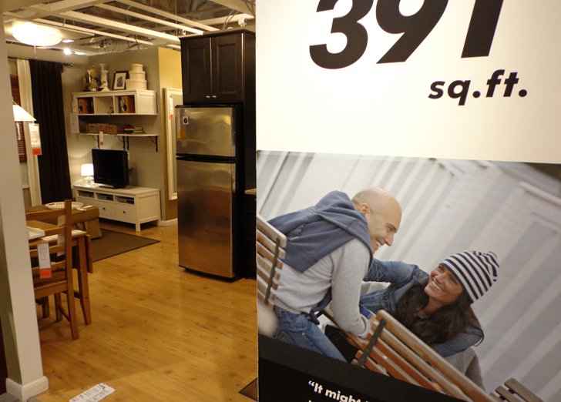

*Inhabitat NYC*

IKEA gives customers an intimate dive with the products they’re selling. They are helping the customers *experience* and *feel*, not just look.

1. Every touchpoint, critical moments when consumers interact with the business, should be deliberately catered for a positive experience.

Furniture shopping is a heavy task. Here are some reasons why I avoid a furniture store like a plague house:

* It’s confusing
* You’re unsure of what to buy
* The kids (or me) start nagging
* You get hungry
* Furniture is heavy
* It’s boring

Based on when a customer walks in to goes back to their home, IKEA sat down and really thought about how they can cater their customer’s touchpoints. As follows:

Confusing? Cruise through the labeled pathway or “route” that winds through the whole store.

Unsure? Sit, lay, touch, open, turn-on anything and everything. It’s all on display.

Nagging Kids? Take them to IKEA’s supervised play place, “Smaland”, for kids and run their energy out.

Hungry? Order Swedish meatballs at their fully-loaded restaurant. Heck, they’ll even subtract the cost of your eating from your total purchase over $150 on certain days.

Ready to buy? Receive a cart from a hydraulic dispenser, go to the warehouse, and get your boxes. You can get it delivered or assembled, or take it home yourself.

Going Home: Either have them deliver and assemble or take it yourself.



IKEA.com

Walk-in, walk-out, IKEA covers the pain points of what would otherwise displease furniture-shopping customers. They emphasize comfort, easiness, accessibility to earn their customers’ time in an age of Amazon and online shopping.

Customer Experience—Takeaways…

Products are important, prices are important, culture is important. But don’t discount the power of making easier of what the customer is actually there to do—shop.

12/28/2016

Expectations and Entrepreneurship

Like a rough wave against a cliffside, failure has eroded me this semester. Yet, like the cliff that takes a new shape after the tide recedes, I’ve come out of my misery with new insight. Specifically, on expectations.

Expectations. They are static, unchanging. Expectations form first as you judge how you want to do, then they harden like molten, not changing until you finish your objective asking yourself, “Ok, how’d I do?”.

And so when I didn’t meet some of my personal expectations this semester, I called myself a loser.

But then I looked at another dimension where expectations were being shattered every day, for better or worse: Entrepreneurship.

Running my small business HS Mixers (HSM), I’ve had expectations from day one. Before I even threw my first “mixer”, a dance for high schoolers, I envisioned huge ragers, numbers hitting 4 digits in attendance, and me scaling my business all across the Bay Area.

Now, let’s reflect back: HSM has thrown 10 great dances, yet none of them have been a huge “rager”. We’ve served over 2,500 students, but no dance has tipped over 600 in attendance. Our business is healthily scaling to 5 cities, but not by myself, rather with a hardworking, robust team of high schoolers.

Right now, we’re doing pretty good, but by my Day-1 definitions I would’ve called myself a failure. What’s the catalyzing difference between my personal and entrepreneurial life?

One of the bedrock lessons in entrepreneurship: Iteration.

Iteration means when you hit a roadblock, or when you don’t meet an expectation or goal, you pivot your strategy. You fail fast and you try another route. And once you’re on that new route, you learn to see if you want to stick with it, or fail again and try another.

Iteration happened the moment I saw small, controlled dances were better than the huge “ragers” I first hoped for, because they were safer and more intimate. From every dance onwards, we focused not on ragers but on systematic, controlled dances. I didn’t meet my initial expectation, but with iteration I learned and achieved something better.

This semester in my personal life, I’m learning to iterate. Which means that if I didn’t end up in the club I interviewed for, I’m going to find out what I did wrong, get better, and see if I want to try something else or interview again with bolstered skills. It means that when that position I ran for didn’t pan out, I’ll use the free time to develop myself in other ways and make new goals. It means I’ll try something new, which could open up even more opportunities.

I realized: If you’re like the cliff and you stand there, rock-solid sure you’re going to stay in the same shape for a while, you may, sometimes. But when the tide comes up and you have the same expectation, you’re going to find yourself in a lot of disappointment because you’re going to get the crap beaten out of you. From the lessons of entrepreneurship:

Embrace failure. Iterate. Then innovate.